Final Project
Deliverable 1

Software Engineering

Anas Bin Rashid i220907
Adan Malik i221000
Hasnain Akhtar i221241

Table of Contents

Title of the Project 2
Problem Statement 2
Features 3
User Stories 4
Team Member Roles 9
Team Agreement 10
GitHub Repository 13
Trello Boards 14

Title of the Project

PetroPulse: A Petrol Station Management Website

Problem Statement

The problem of | inefficient and error-prone petrol station operations
affects | petrol station owners, employees, and customers,
the impact of which is | loss of revenue, inventory mismanagement, customer dissatisfaction, and security risks, mismanaged service shifts,
a successful solution would be | a centralized petrol station management system that automates fuel sales, inventory tracking, worker management, and customer loyalty programs while integrating with financial systems. PetroPulse will provide a comprehensive management solution by integrating sales tracking, automated reporting, and real-time fuel level monitoring. The system will ensure smooth operations by incorporating a secure payment mechanism, worker scheduling, and calculations for stock refills. Additionally, it will support customer engagement through a loyalty points program and provide remote access to station owners.

Features

- User Authentication (Owner, Employee, Customer roles)
- Fuel Inventory Management (Real-time tracking, automated stock refill requests)
- Sales Tracking & Reports
- Payment Processing (Cash, Card)
- Worker Management (Shift management, attendance, check-in system)
- Customer Management (Membership, support, chat assistance)
- Loyalty Points System
- Fuel Dispensing Monitoring
- Station Maintenance
- Supplier & Vendor Management (Order processing, tracking)
- Multi-Station Management (For owners of multiple stations)
- Dynamic Fuel Pricing System (Price adjustments based on market trends)
- Remote Access
- Low Fuel Alerts
- Customer Feedback System
- Discounts & Promotions System (Bulk fuel purchase discounts)
- Employee Performance Tracking & Reports
- Financial Reporting Integration (Tax & compliance reporting)
- Security & Fraud Detection
- Analytics & Reporting Dashboard
- Transaction History & Auditing
- Exportable Reports (CSV, PDF)
- Real-time Alerts & Notifications (Email, SMS)
- Role-based Access Control
- API for Third-Party Integration
- User-friendly UI/UX
- Government Fuel Regulations Follow-Up
- Configurable Taxation Module
- Support for Multiple Fuel Types
- Vehicle Registration for Fuel Requests

User Stories

ID | User Story | Acceptance Criteria | Estimation | Priority
1 | User Registration - As a new user, I want to register on the system so that I can access PetroPulse services. | Given: A new user navigates to the registration page. When: They provide valid details (name, email, phone, password). Then: The system successfully creates an account and sends a confirmation email. | 3 | High
2 | User Login - As a registered user, I want to log into the system so that I can access my dashboard. | Given: A user is on the login page. When: They enter valid credentials. Then: The system grants access to their dashboard. | 2 | High
3 | Password Reset - As a user, I want to reset my password so that I can regain access to my account if I forget it. | Given: A user is on the login page. When: They click on "Forgot Password" and enter their email. Then: The system sends a password reset link to their email. | 3 | Medium
4 | Add Fuel Station - As an owner, I want to add new fuel stations so that I can manage multiple stations in the system. | Given: An owner is logged in. When: They enter station details and submit the form. Then: The system registers the new station and updates the list. | 3 | High
5 | View Fuel Stations - As an owner, I want to view a list of my fuel stations so that I can manage their operations efficiently. | Given: The owner is on the dashboard. When: They navigate to the "Manage Stations" section. Then: The system displays a list of owned stations. | 2 | High
6 | Update Fuel Station Details - As an owner, I want to update my fuel station details so that I can keep the information accurate. | Given: The owner is on the "Manage Stations" page. When: They update station details and save changes. Then: The system reflects the updated details. | 3 | Medium
7 | Remove Fuel Station - As an owner, I want to remove a fuel station so that I can stop managing a closed or sold station. | Given: The owner is on the "Manage Stations" page. When: They click delete and confirm the action. Then: The system removes the station from the database. | 3 | Medium
8 | Register Workers - As a station owner, I want to register workers so that they can manage station activities. | Given: The owner is on the "Manage Workers" page. When: They enter the worker's details and submit. Then: The system registers the worker. | 3 | High
9 | Assign Workers to Stations - As an owner, I want to assign workers to specific stations so that they can operate in their designated locations. | Given: An owner is on the worker management page. When: They select a worker and assign a station. Then: The system updates the worker's assigned station. | 3 | Medium
10 | Worker Login - As a worker, I want to log into the system so that I can manage station operations. | Given: A worker is on the login page. When: They enter valid credentials. Then: The system grants access to the worker dashboard. | 2 | High
11 | Record Fuel Sales - As a worker, I want to record fuel sales so that the system tracks all transactions. | Given: A worker is logged in. When: They enter fuel sale details. Then: The system stores the transaction. | 3 | High
12 | Generate Sales Reports - As an owner, I want to generate sales reports so that I can analyze revenue and performance. | Given: The owner is on the reports page. When: They select a date range and generate a report. Then: The system displays the sales data. | 3 | High
13 | Track Fuel Inventory - As a station owner, I want to track fuel levels so that I can ensure continuous supply. | Given: The owner is on the dashboard. When: They check the station inventory. Then: The system displays real-time fuel levels. | 4 | High
14 | Alert for Low Fuel Levels - As a station owner, I want to receive alerts for low fuel levels so that I can order refills in time. | Given: A station's fuel level drops below a threshold. When: The system detects the low level. Then: It sends an alert to the owner. | 3 | High
15 | Order Fuel Supply - As an owner, I want to order fuel refills so that my stations never run out of stock. | Given: The owner is on the fuel supply page. When: They place an order for fuel. Then: The system processes and confirms the order. | 4 | High
16 | View Loyalty Points - As a customer, I want to view my loyalty points so that I can track my rewards. | Given: A customer is logged in. When: They navigate to the "Loyalty Points" page. Then: The system displays their current balance. | 2 | Medium
17 | Redeem Loyalty Points - As a customer, I want to redeem my loyalty points so that I can get fuel discounts. | Given: A customer has sufficient points. When: They redeem them at checkout. Then: The system applies the discount. | 3 | Medium
18 | Customer Fuel Purchase - As a customer, I want to purchase fuel from the station so that I can refuel my vehicle. | Given: A customer is at a station. When: They choose the fuel type, quantity, and payment method. Then: The system processes the payment and updates inventory. | 4 | High
19 | Manage Pricing for Fuel Types - As a station owner, I want to update fuel prices so that I can adjust them based on market conditions. | Given: The owner is on the pricing page. When: They update the price of a fuel type. Then: The system reflects the new pricing in real time. | 3 | High
20 | Manage Maintenance Requests - As a station owner, I want to log maintenance requests so that I can ensure station upkeep. | Given: A station has an issue. When: The owner submits a maintenance request. Then: The system records and tracks the request. | 3 | Medium
21 | View Transaction History - As a customer, I want to view my transaction history, so that I can track my fuel purchases. | Given: A customer is logged in,  When: They navigate to the transactions section,  Then: The system displays all past fuel purchases. | 2 | Medium
22 | Payment via Cash - As a customer, I want to pay for fuel using cash, so that I can complete my purchase without a card. | Given: A customer selects fuel,  When: They choose cash as the payment method,  Then: The system registers the payment and updates records. | 3 | High
23 | Payment via Card - As a customer, I want to pay for fuel using my debit/credit card, so that I can make transactions easily. | Given: A customer selects fuel,  When: They choose card as the payment method,  Then: The system processes the payment and updates records. | 3 | High
24 | Manage Supplier Information - As an owner,  I want to manage my fuel suppliers,  So that I can track orders and deliveries. | Given: The owner is on the supplier management page,  When: They add, edit, or remove a supplier,  Then: The system updates the supplier database. | 3 | Medium
25 | Generate Maintenance Reports - As an owner,  I want to track station maintenance, so that I can schedule repairs and ensure smooth operations. | Given: The owner is on the reports page,  When: They request a maintenance report,  Then: The system provides a list of past and upcoming maintenance tasks. | 3 | Medium
26 | Employee Attendance Tracking - As a station owner,  I want to track employee attendance, so that I can monitor working hours. | Given: A worker logs into the system,  When: They mark attendance for the shift,  Then: The system records their working hours. | 3 | Medium
27 | Secure Access - As a user,  I want to have secure access to system configurations, so that I can manage system settings safely. | Given: The user is on the login page,  When: They enter valid admin credentials,  Then: The system grants access to the admin panel. | 3 | High
28 | View Worker Profiles - As an owner, I want to view worker profiles, so I can manage their information and roles. | Given: The owner is on the "Manage Workers" page. When: They select a worker profile. Then: The system displays the worker's details. | 2 | Medium

Team Member Roles

Product Owner – Hasnain Akhtar
Responsibilities:
- Define and prioritize user stories for the Petroleum Management System.
- Ensure that features such as fuel request handling, inventory tracking, and payment processing align with stakeholder needs.
- Communicate business requirements clearly to the development team.
- Accept or reject completed user stories based on their adherence to acceptance criteria.
- Continuously refine the backlog based on feedback from stakeholders and the development team.

Scrum Master – Anas Bin Rashid
Responsibilities:
- Facilitate Agile ceremonies such as Sprint Planning, Daily Standups, Sprint Review, and Retrospective.
- Identify and remove blockers affecting the development of features like shift management, employee check-in, and real-time alerts.
- Ensure smooth collaboration between Hasnain (Product Owner) and Adan (Developer).
- Track sprint progress and ensure adherence to Agile principles.
- Guide the team in improving workflow efficiency and maintaining high productivity.

Scrum Team – Adan Malik, Anas Bin Rashid, Hasnain Akhtar
Responsibilities:
- Develop and implement features such as fuel request processing, analytics dashboard, and customer profile management.
- Ensure code quality, security, and efficiency while integrating various modules.
- Conduct unit testing and debugging to ensure smooth system functionality.
- Collaborate with Hasnain (Product Owner) to clarify feature requirements and address feedback.
- Participate in sprint planning and daily standups to track development progress.

Team Agreement

To ensure smooth collaboration and efficient progress in our project, we have established the following team agreement. This will serve as a guideline for how we communicate, work, and handle challenges as a team.

1. Methods of Communication
- Primary Communication: WhatsApp (for quick discussions, updates, and file sharing).
- Secondary Communication: Email (for formal communication, documentation sharing, and reporting).
- Phone Calls: Only for emergencies or when detailed discussions are needed.

2. Communication Response Times
- WhatsApp: Within 1-2 hours during working hours.
- Emails: Within 24 hours unless marked urgent.
- Phone Calls: Immediate response if available; if missed, return within 2 hours.

3. Meeting Attendance
- Sprint Planning, Sprint Review, and Retrospectives are mandatory for all members.
- Daily Standups: Attendance is expected unless there's an emergency. Updates can be given asynchronously if someone is unavailable.
- Ad-hoc Meetings: Attendance is encouraged but can be flexible based on availability.

4. Running Meetings
- When: Sprint meetings will be held on Mondays; Retrospectives on Fridays.
- Where: Mostly online (Google Meet/Zoom); in-person meetings when necessary.
- Minutes/Notes: The Scrum Master (Anas) will document key decisions and action points.

5. Meeting Preparation
- Team members should review the agenda before meetings.
- Any assigned tasks must be completed or have a clear progress update ready.
- The Product Owner (Hasnain) should come prepared with backlog updates and priorities.

6. Version Control
- Repository: We will use GitHub for version control.
- Commit Guidelines:
  - Clear and descriptive commit messages (e.g., Added fuel request API, Fixed payment processing bug).
  - No committing untested or broken code.
  - Feature branches should be used before merging to the main branch.
- What NOT to Commit:
  - Personal credentials or sensitive data.
  - Debug logs, temporary files, or compiled binaries.

7. Division of Work
- Tasks will be assigned based on expertise and workload balance.
- The Product Owner (Hasnain) will define priorities, and the Scrum Master (Anas) will ensure fair task distribution.
- The Developer (Adan) will be responsible for implementation but will collaborate with the team on technical decisions.
- Stakeholders: Product Owner, Scrum Master, Developers, End-users (fuel station managers, suppliers).

8. Submitting Assignments
- Deadline: All tasks must be completed at least 3 hours before the sprint ends for review.
- Who submits? The Scrum Master (Anas) will submit final deliverables.
- Who reviews? The Product Owner (Hasnain) will conduct a final review to ensure alignment with business needs.

9. Contingency Planning
- If a team member drops out: Responsibilities will be redistributed based on workload and expertise.
- If a team member misses meetings consistently: A one-on-one discussion will be held to address concerns. If the issue persists, the team will escalate accordingly.
- If a team member is academically dishonest: The incident will be reported following the academic integrity policies.

GitHub Repository

Repository Link: https://github.com/anasbinrashid/Petrol-Station-Management-Station-Website

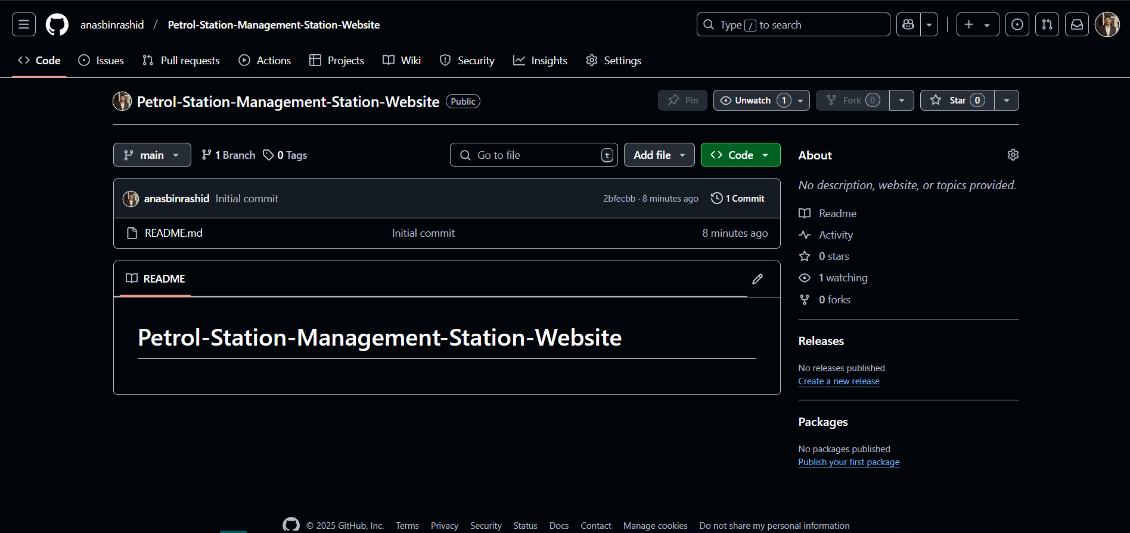

Trello Boards

  - Sprint Backlog
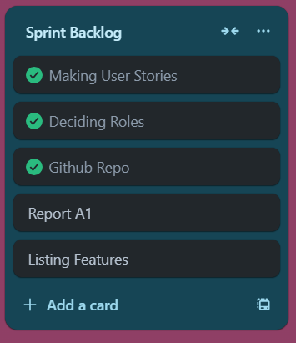

  - Product Backlog
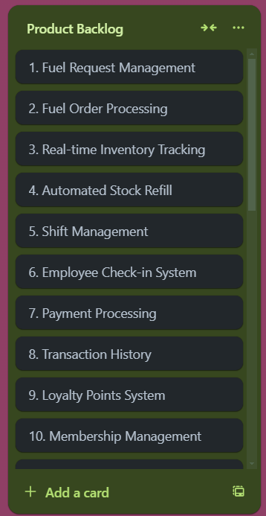

  - Complete Trello Board

